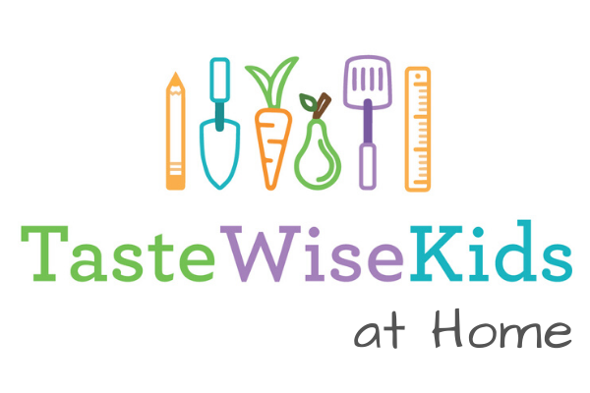
Activity: Making a Salad
Today’s activity is pretty simple - make a salad! Before we get into the specifics, when you make your salad make sure to think about HOW you balance tastes as you pick ingredients. (If you need a refresher on the tastes and how to balance them, check out our How to be a Sensory Sleuth activities).
Here’s a tip from one of our TasteWise Kids experts, Days of Taste Director Riva Kahn, about how to taste your salad dressing:
Tear off a small piece of lettuce, rinse and pat dry, then dip into the dressing and taste. Adjust the dressing ingredients to suit your taste. For example, if it’s too sour, add more honey, or if it too sweet, add more vinegar. You can always add more, but you cannot take out ingredients once added!
Activity 1: Real Salad
As for making your salad, you can do it a few different ways. Regardless of which way you choose, we suggest reading through all of these ideas as we included some cool resources even if you make salad another way.
- Get in your kitchen and try out Chef Carlos’s recipe or another one of the many salad recipes we have collected from our chef and food industry partners!
- Use the “mix and match” method that we show in our How to Build a Salad sheet. Remember you don’t have to use lettuce as the base ingredient.
- Do a google search and find a new salad recipe that you want to try - here’s a couple sites with good recipes that kids can make:
  - Chop Chop Family
  - America's Test Kitchen - Kids
  - UMD Eat Smart Recipe Search
- Make one salad but 2 salad dressings or vinaigrettes. See which one you like better.
  - Need an idea for a vignette? Watch legendary French chef Jacques Pepin’s quick and easy vinaigrette with just a few, simple ingredients - this is the same vinaigrette we often make with students so we know it’s kid-approved! (see our Want to Keep Learning section below for a fun experiment you can do to understand how ingredients come together to make a creamy vinaigrette).

Activity 2: Envisioned Salad
You don’t even have to get into the kitchen to make your salad! Create your own perfect salad from your imagination. Even if you do make a salad to eat, try this activity anyways as it is a lot of fun to get to use ANY ingredients you want. Nothing is holding you back.
- Grab a piece of paper and draw a big circle (maybe trace a plate to get an exact circle) in the middle.
- Brainstorm ideas:
  - Think about what might be sweet, sour, salty and bitter? Do you want to add in a protein too (our How to Make a Salad sheet can help with ideas)?
  - If you have any old magazines, delivery menus, or newspapers around, you could cut out pictures of food to add in.
  - Go online for ideas - google salad recipes or use one of ours like Bryce Taylor’s yummy Shrimp & Strawberry salad or Gertrude’s Days of Taste salad
- Draw your salad - add in ingredients that you think would make a balanced salad. You can draw in pencil, make a collage, use words to describe your items - anything works. Just be creative and think like a Chef!
- If you have lots of ideas, make more than one salad - find a family member or friend to judge which one “tastes” best.
Debrief/Key Points
- Salads can include a range of ingredients - doesn’t even have to have lettuce! Think about grains, beans, and your favorite foods, such as Carlos' Doritos!
- To make a balanced salad, include foods that have different tastes (sweet, sour, bitter, salty).

